Arch Linux - Installation Guidelines
First version: MARCH 25, 2022 / 6:22 PM CT
Last update: APRIL 28, 2023 / 00:16 AM CT
00 Arch Linux ISO file
- I’m assuming you already downloaded your Arch ISO, the image can be burned to a CD/DVD, mounted as an ISO file, or be directly written to a USB stick: https://archlinux.org/download/
- Once the ISO is loaded, and you see the zsh command prompt, if you are installing Arch Linux on a VM, you can connect remotely via ssh, first, you will need to install the following packages:
# sudo pacman -Syy reflector openssh virtualbox-guest-utils
- You need to enable/start the ssh service:
# systemctl start sshd
- You need to set the password for the root user with:
# passwd
- Next, you need to find out what’s your IP address:
# ip -c a
If you need to connect to Wi-Fi, you’ll connect to the wireless networks with iwd following this process (https://wiki.archlinux.org/title/Iwd#iwctl):
# iwctl
-- to find the name of our Wireless adapter:
[iwd]# device list
-- next, we need to scan the networks available to Us (for this example the device name found on the previous step was wlan0):
[iwd]# station wlan0 scan
-- next, we need to display the networks available to Us:
[iwd]# station wlan0 get-networks
-- next, to connect to the desired network, you’ll be requested to enter the password for this network:
[iwd]# station wlan0 connect <network-WiFi-name>
-- Exit the Wireless connection tool to go back to the root ISO:
[iwd]# exit
Once you know your IP, you can continue the installation of Arch Linux from your favorite terminal, something like this should do the ssh connection, per instance:
# ssh root@192.168.XXX.XXX

01 Sync your Network Time Protocol
# timedatectl set-ntp true
# reflector -c US -a 6 --f 20 --protocol https --sort rate --save /etc/pacman.d/mirrorlist
# sudo pacman -Syy
02 We will work on disk partition now…
First, we can try with the BTRFS file system, there are like a dozen different ways to do this, for this example we will install Arch on a disk called “sda”, so your disk could be something else, make sure to use the correct name:
- # lsblk
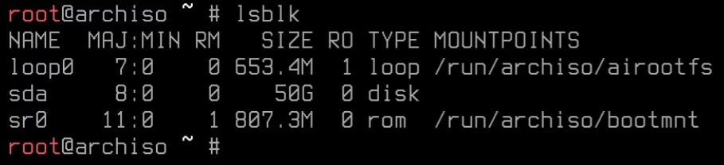
- First, let’s do the disk partition with
# gdisk <the path of the disk> and enter “n” for new.
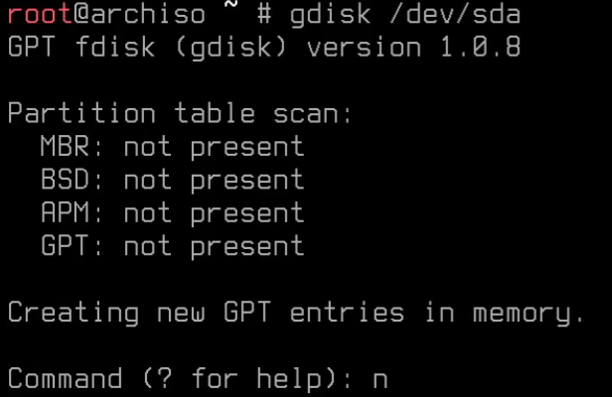
- This is just an example of how to do your disk partition:
I am doing the partition on a brand-new disk, the first partition I am creating is for EFI (300Mb), the second will have the rest of the disk, because we will use ZRam for the swap and BTRFS with multiple sub-volumes:
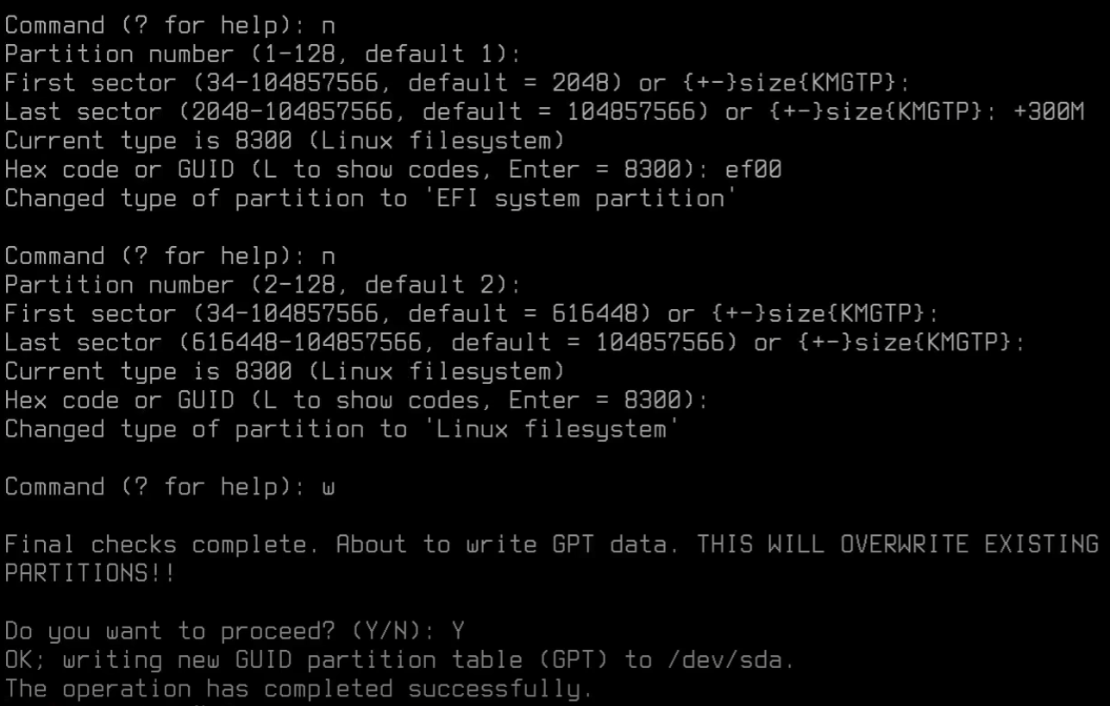
# lsblk
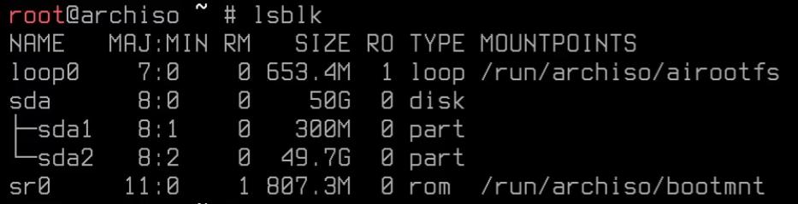
- The next step is formatting the disk partitions (for this example, vda1 is the EFI partition, vda2 is the BTRFS file system):
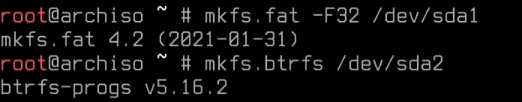
This could be something like:
# mkfs.fat -F32 /dev/nvme1n1p1
# mkfs.btrfs /dev/nvme1n1p2
- Next we need to mount our partitions, first we need to mount the root partition, then create our BTRFS sub-volumes and mount them with specific options (we will take snapshots only of the root sub-volume), as always, feel free to change this according to your needs:
# mount /dev/sda2 /mnt
( mount /dev/nvme1n1p2 /mnt )
# cd /mnt
/mnt# btrfs subvolume create @
/mnt# btrfs subvolume create @home
/mnt# cd
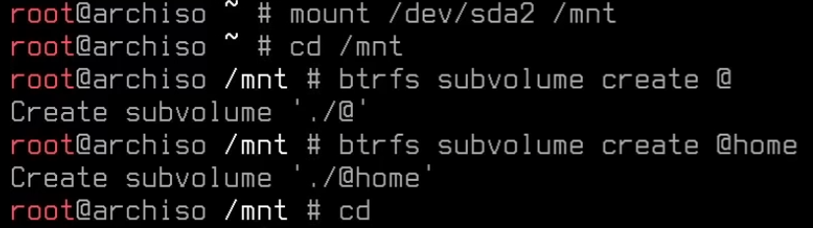
- Next, we need to unmount our /mnt directory because later we need to re-mount the sub-volumes into their respective directories using some options:
# umount /mnt
# mount -o noatime,compress=zstd,ssd,discard=async,space_cache=v2,subvol=@ /dev/vda2 (/dev/nvme1n1p2) /mnt
# mkdir -p /mnt/{boot,home}
# mount -o noatime,compress=zstd,ssd,discard=async,space_cache=v2,subvol=@home /dev/vda2 (/dev/nvme1n1p2) /mnt/home
# mount /dev/sda1 (/dev/nvme1n1p1) /mnt/boot
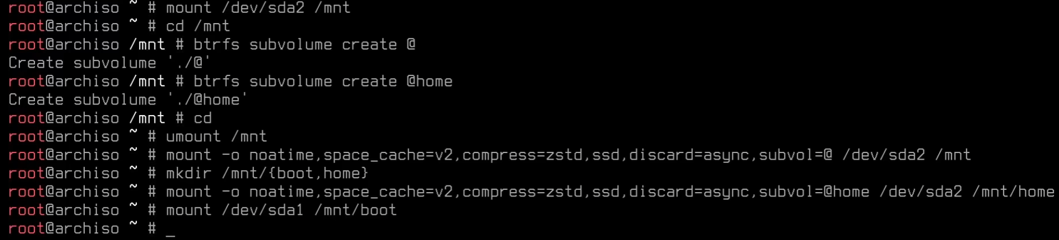
# lsblk
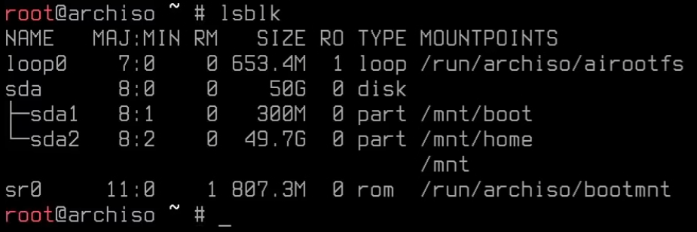

03 Installation of the base packages on the new system:
# pacstrap /mnt base linux linux-firmware vim amd-ucode git
04 Generate the file system table
# genfstab -U /mnt >> /mnt/etc/fstab
# cat /mnt/etc/fstab
05 Moving to the installation as root
# arch-chroot /mnt
05 Time to install the base system
- We will use the following scripts from this public repository:
# git clone https://gitlab.com/eflinux/arch-basic.git
- Navigate to the base-uefi.sh and modify the packages and the script to your liking
- Make the script executable with chmod +x base-uefi.sh and then run with ./base-uefi.sh
- The script does the following:
# ln -sf /usr/share/zoneinfo/US/Central /etc/localtime
# hwclock --systohc
# vim /etc/locale.gen
Uncomment the line for English US (or whatever you need), then, save the file and exit VIM:
# en_US.UTF-8 UTF-8
Generate the locale:
# locale-gen
Create the locale file with this information:
# echo “LANG=en_US.UTF-8” >> /etc/locale.conf
# echo “arch” >> /etc/hostname
Also, you need to set the hosts file:
# vim /etc/hosts
Then, you enter the following, then, save the file and exit VIM (:x)
127.0.0.1 localhost
::1 localhost
127.0.1.1 arch.localdomain arch
You can set the root password if not done already:
# passwd
Then, install the bootloader and some other packages:
# pacman -S grub efibootmgr networkmanager network-manager-applet dialog os-prober snapper mtools dosfstools base-devel linux-headers bluez bluez-utils cups reflector openssh git xdg-utils xdg-user-dirs alsa-utils pulseaudio pulseaudio-bluetooth inetutils bash-completion terminus-font rsync dnsutils nfs-utils nvidia nvidia-utils nvidia-settings xf86-video-amdgpu sof-firmware ntfs-3g bat lolcat
Before installing the bootloader, we need to change something into the cpio file because we are using the BTRFS file system:
# vim /etc/mkinitcpio.conf
On the modules section, we need to add btrfs (and nvidia if using real hardware). Then, save the file and exit VIM. Then, re-generate the kernel image with:
# mkinitcpio -p linux
# grub-install --target=x86_64-efi --efi-directory=/boot --bootloader-id=GRUB --removable (and make sure to enable UEFI mode from bios, otherwise it will not boot).
If we have other operative system installed already, and we need to boot from multiple OSs, we need to tell GRUB to “do not disable” os-prober executing the following steps to update the configuration file for GRUB:
# vim /etc/default/grub
If not present, add this entry at the end of the file, save the file, and exit VIM:
GRUB_DISABLE_OS_PROBER=false
Lastly, we run the GRUB configuration file
# grub-mkconfig -o /boot/grub/grub.cfg
Next, enable some services:
# systemctl enable NetworkManager
# systemctl enable sshd
# systemctl enable cups
# systemctl enable bluetooth
# systemctl enable fstrim.timer
Next, add a new user and give it sudo privileges:
# useradd -mG wheel neo
# passwd neo
# EDITOR=vim visudo
Go down until you find the wheel group and uncomment this line, later, save the file and exit VIM:
%wheel ALL=(ALL) ALL
# exit (to go back to the ISO)
# umount -R /mnt
# reboot

06 Login with your user and install the XFCE desktop environment
- # setfont ter-132n
- Next, you need to find out what’s your IP address:
# ip -c a
- If needed, we can connect to the Wi-Fi using the Network Manager terminal user interface, where you will be able to activate a connection and enter the password for the same:
$ nmtui
# timedatectl set-ntp true
# hwclock --systohc
# reflector -c US -a 6 --f 15 --protocol https --sort rate --save /etc/pacman.d/mirrorlist
$ sudo pacman -Syy
$ sudo pacman -S xorg lightdm lightdm-gtk-greeter xfce4 xfce4-goodies firefox-developer-edition materia-gtk-theme papirus-icon-theme simplescreenrecorder vlc dina-font tamsyn-font ttf-bitstream-vera ttf-croscore ttf-dejavu ttf-droid gnu-free-fonts ttf-ibm-plex ttf-liberation ttf-linux-libertine noto-fonts ttf-roboto tex-gyre-fonts ttf-anonymous-pro ttf-cascadia-code adobe-source-code-pro-fonts cantarell-fonts ttf-opensans lolcat archlinux-wallpaper xreader
$ sudo systemctl enable lightdm
# reboot
- Installing PARU AUR Helper
$ sudo pacman -S --needed base-devel
$ git clone https://aur.archlinux.org/paru.git
$ cd paru
$ makepkg -si
- Installing firmware packages:
$ sudo pacman -S linux-firmware-qlogic
$ paru -S aic94xx-firmware wd719x-firmware upd72020x-fw
- Installing timeshift and zramd
$ paru -S timeshift timeshift-autosnap zramd
From the main menu, open timeshift to do the configuration the first time.
Enable zramd:
$ sudo systemctl enable --now zramd.service
$ lsblk (just to make sure is active and running)
** NOTICE: I cannot and will not be liable responsible for any lost of data or information, nor any damage to your hardware. THE SOFTWARE IS PROVIDED “AS IS”, WITHOUT WARRANTY OF ANY KIND, EXPRESS OR IMPLIED, INCLUDING BUT NOT LIMITED TO THE WARRANTIES OF MERCHANTABILITY, FITNESS FOR A PARTICULAR PURPOSE AND NONINFRINGEMENT. IN NO EVENT SHALL THE AUTHORS BE LIABLE FOR ANY CLAIM, DAMAGES OR OTHER LIABILITY, WHETHER IN AN ACTION OF CONTRACT, TORT OR OTHERWISE, ARISING FROM, OUT OF OR IN CONNECTION WITH THE SOFTWARE OR THE USE OR OTHER DEALINGS IN THE SOFTWARE. **

